CITIZEN AI: Intelligent Citizen Engagement Platform

**1.INTRODUCTION**:

Citizen AI: Intelligent Citizen Engagement Platform

**TEAM MEMBERS:**

S.Vishnu

B.Aadhithyan

K.Moorthy kannan

**2. PROJECT OVERVIEW:**

The Citizen AI platform is a cutting-edge, AI-driven solution designed to enhance citizen engagement, improve government services, and foster a more responsive and inclusive community. Here’s a comprehensive overview

* **Conversation Interface:**

A Conversation Interface in a Citizen AI Platform enables citizens to engage with government through natural chat or voice

It creates an intelligence engage system for faster services transparent communication and data-driven governance

* **Policy Summarization:**

Citizen Al uses policy summarization to present complex rules in simple, clear anguage for citizens.

This makes governance more transparent, accessible, and easy to understand for everyone.

**• Resources Forecasting**

Citizen AI applies resource forEcasting to predict future needs and demands.

This helps governments ensure efficient allocation and timely delivery of public services.

**• Eco- Tip Generator**

Citizen AI's eco tip generator gives citizens daily suggestions to live sustainably. It promotes green habits and community-wide environmental awareness.

**• Citizen Feedback Loop**

Citizen Al's feedback loop collects and analyzes public opinions in real time. This ensures comtinuous improvement of services and stronger citizen trust.

**• KPI Fore Casting**

Citizen Al usEs KPI forecasting to prcdict key performance outcomes of public services. This Enables data-driven planning and proactive governance.

**• Anomaly Detection**

Citizen AT's anomaly detection spots unusual patterns in citizen data or service use. This helps ensure carly issuc detection and quick corrective action.

**• Multimodal Input Support**

Citizen Al's multimodal input support lets citizens interact via text, voice, or images. It ensures inclusive, accessible, and user-friendly engagement for all.

**• Streamlit to Gradio Ui**

Citizen Al can shift from Streamlit to Gradio Ul for more interactive, flexible citizen engagement.

This enables seamless A/ demos, faster prototyping, and user-friendly interfaces.

**3.ARCHITECTURE:**

The architecture of Citizen Al integrates data sources, AI models, and citizen-facing interfaces.

It ensures secure, scalable, and efficient intelligent engagement across services.

**• LLM Integration**

Citizen AI's LLM integration enables natural, human-like conversations with citizens.

It provides context-aware answers and personalized service delivery.

**• Vector Sector**

Citizen AI's vector search orgunizes and retrieves information with high accuracy.

lt enables fast, relevant, and context-aware citizen query responses.

**• ML Modules**

Citizen Al's ML modules analyze pattcrns in citizen data to improve decision-nmaking.

They enable predictive insights and smarter public service delivery.

**4.SETUP INSTRUCTION:**

Set up Citizen AI by deploying Al/ML models with secure data integration across services.

Then configure multichannel interfaces (chat, voice, web) for citizen interaction**.**

**• Prerequisites**

A citizen engagement platform requires secure infrastructure and integrated data sources.

It also needs Al/ML tools with multilingual, accessible user interfaces for effective

interaction.

**• Installation Process**

The installation process involves configuring servers, databases, and AI/ML environments.

Next, deploy the citizen-facing UI with security, multilingual, and accessibility features.

**5.FOLDER STRUCTURE:**

The folder structure includes separate modules for data, models, APIs, and UI components.

It ensures organized development, easy scaling, and smooth maintenance**.**

**6.RUNNING THE APPLICATION:**

Run the Citizen AI application by starting backend services and launching the UI interface.

Citizens can then interact in real time through chat, voice, or web platforms.

**7.API D0CUMENTATION:**

The API documentation provides detailed endpoints, request/response formats, and

authentication methods.

It enables developers to integrate and interact with the Citizen AI platform efficiently.

**8.AUTHENTICATION:**

Citizen AI uses secure authentication methods like OAuth, JWT, or API keys.

This ensures only authorized users access services and sensitive citizen data.

**9.USER INTERFACE:**

The Citizen Al user interface offers intuitive chat, voice, and web interactions.

It ensures easy, accessible, and engaging citizen engagement across platforms**.**

**10.TESTING:**

Testing Citizen AI involves validating AI responses, system workflows, and data integration**.**

It ensures accuracy, reliability, and seamless citizen interaction.

**11.KNOWN ISSUES:**

Known issues may inchude misinterpretation of queries, latency in responses, or integration

bugs.

Addressing them ensures improved accuracy and smoother citizen engagement.

**12.FUTURE ENHANCEMENT:**

Future enhancements include advanced multilingual support, predictive analytics, and

proactive citizen alerts.

These upgrades aim to increase engagement, efficiency, and personalized public services**.**

**13.PROJECT SCREENSHOT:**

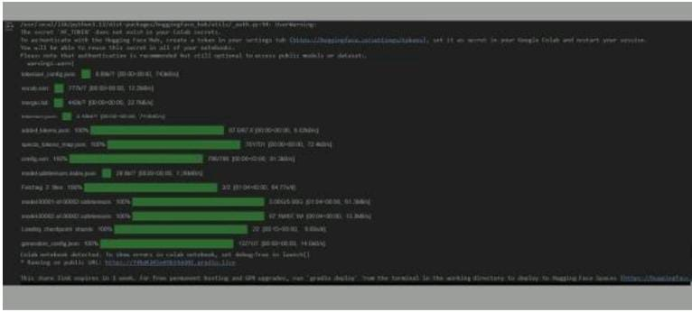

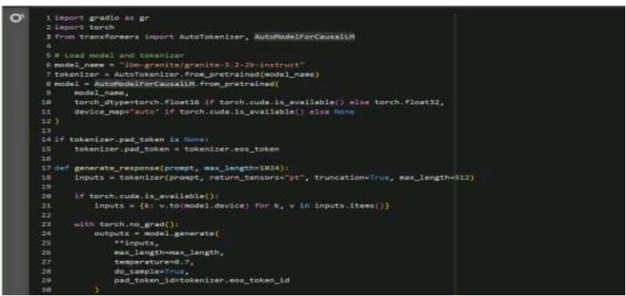

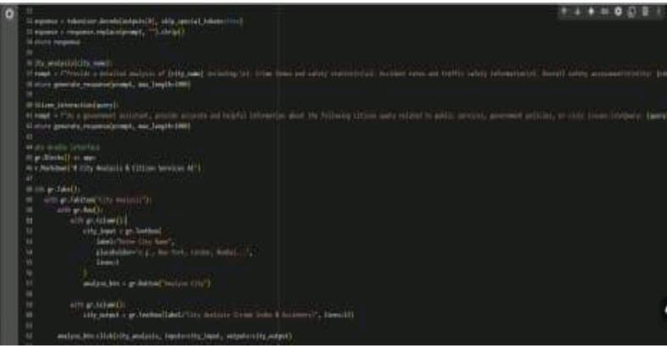

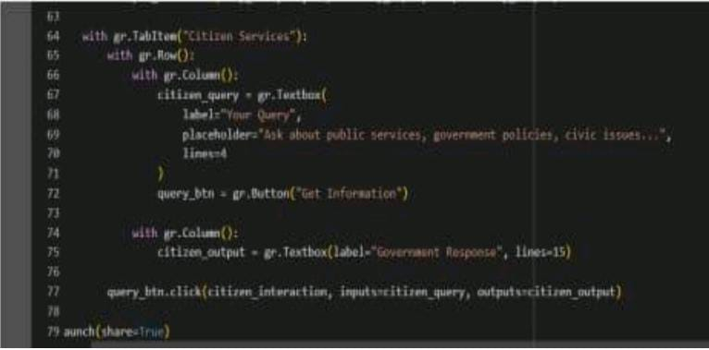

**THANK YOU…**